- 此表格只用作遷離書院之用。 / This form is for student moving out from College only.
參考編號 / Reference No.:

1. 學生資料 / Student Information
書院/Residential College: CKPC CYTC CKLC CKYC FPJC LCWC MLC MCMC SPC SEAC
姓名/Name: |  | 學生證號碼/Student No.:
流動電話/Mobile No.: |  | 房間號碼/Room No.:
電郵/E-mail:
2. 辦理遷離書院方法 / Method of Move-out (請選其中一項 / Please choose one option)
本人自行辦理遷離書院手續 / I will process the move-out procedure by myself.
本人授權 / I authorize (學生證號 / Student No.) |  | (姓名 / Name)
□ 辦理遷離書院手續（需另交授權書）/ to process the move-out procedure on my behalf. (Authorization needed)
* 有關離校學生的保證金退還方式，請見下一版。 / Regarding the method of collection of security deposit for the student who is processing the check-out procedure of the University, please refer to the next page.

收集個人資料聲明 / Personal Data Collection Statement
- 澳門大學根據第1/2006號法律作為一所公立高等教育機構，將處理在本表格內所收集的個人資料作舉辦活動、提供服務及聯絡之用。
The University of Macau being a public institution of higher education as set in Law No. 1/2006, will process the personal data collected on this form for activity organization, service providing and contact purposes.
- 基於活動或服務所需，上述個人資料有可能轉交本澳或外地相關機構。
Due to the needs of the activity or service, the personal data on this form may be transferred to other organizations in or outside Macao.
- 申請人有權依法申請查閱、更正或更新其存於本校的個人資料。
The applicants have the right to access, rectify or update their personal data stored at UM.
學生簽名 / Signature: |  | 日期 / Date:

此欄由書院辦公室填寫 / Filled by General Office
學生遷離日期/Move-out on the date of: |  | (年/yyyy) |  | (月/mm) |  | (日/dd)

有/Yes | 無/No | 項目/Items |  | 金額*/Amount* | 備註/Remark
 |  |  | 電費應付 / Electricity payable
 |  |  | 水費應付 / Water payable
 |  |  | 暑期住宿費 / Summer stay fee
 |  |  | 其他費用 / Others (請註明 / Please Specify):
* 只適用於離校學生或其他特定情況 / Only applicable to the student who is processing the check-out procedure of the University, or other specified cases.

院生已歸還所有門匙 / Student returned all the door keys
已更新學生住宿系統 / Housing System has been updated

處理人簽名/Handled by: |  | 日期 / Date:

保證金退還方式 / Method of Collection of Security Deposit
只適用於離校學生 / Only applicable to student who is processing the check-out procedure of the University
大學將以自動轉賬方式退還保證金至學生本人於學生資訊網登記之澳門本地銀行賬戶。
The university will refund the security deposit via autopay to the student’s registered Macau bank account in SI Web.

外地交流生可親臨財務部出納處櫃檯，以現金方式取回已繳的保證金。
Exchange student can collect the security deposit in cash by visiting the Treasury counter of Finance Office in person.

倘選擇以下退款方式：
For choosing the following methods to receive the refund:

- 電匯：請透過財務部網頁提供的連結填妥匯款資料，並注意所有涉及之銀行匯款費用須由收款人承擔。
Telegraphic transfer: Please provide the remittance information via the link provided on the Finance Office website, and note that all remittance charges are borne by the recipient.
- 授權他人代為取回保證金：請填妥“學生退款授權書”，並附上雙方身份證明文件及被授權人的銀行賬戶資料，一併上傳至財務部網頁所提供的連結。
Authorizing another person to receive the refund: Please complete the “Authorization Letter for Student Refund”, and attach copies of both parties’ identification documents, as well as the authorized person’s bank account information, then upload them to the link provided on the Finance Office website.

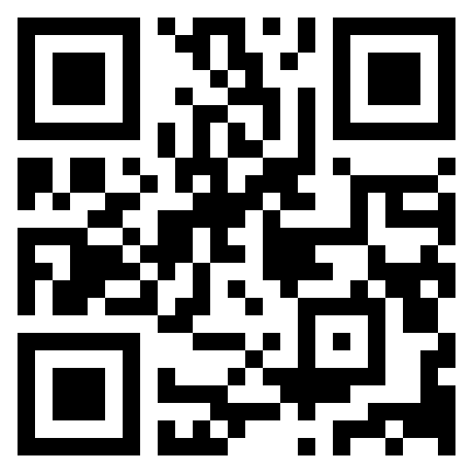
財務部網頁連結
Finance Office website link

出納處專用 / For Treasury Section Use Only
保證金退還確認 / Acknowledgment of Collection of Security Deposit
本人________________________已取回預繳之保證金，金額為________________________澳門元。

I, ______________________, have received the refund of the security deposit of MOP______________________.

收款人/Receiver: ___________________________ 日期/Date:_______________________________

